Kingdom of Saudi Arabia  Ministry of Education  Hafr Al Baten Educational Directorate for boys  Tarbeat Al –Ajial International Schools |  |  |  |   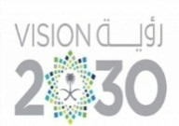 |  |  | Date: 2025 / 10 / 26  Subject: Computer  Class.: 2  Time: 40 minutes
……………… |  | Seat Number |  | ……………………………………….. |  |  |  | Student’s Name
Mid-Term Exam (1st Semester) 2025/2026
Sign. | Consultative Name |  | Sign. |  | Corrector’s Name | Marks in letters |  |  | Marks  in numbers
 |  |  |  |  |  |  |  |  | 20

Q1: Match the following:
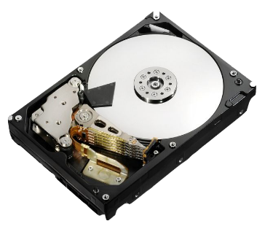 | Folder
 | Hard Disk
 | C: Drive
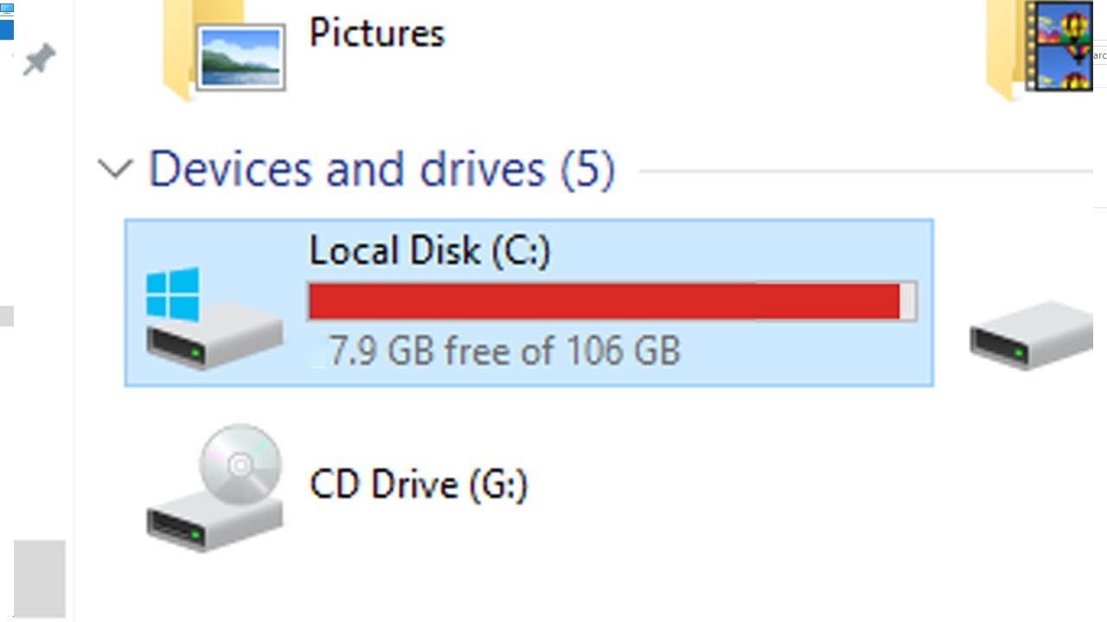 | File

Q2: write the correct name of each part:
Image | Recycle Bin | Mouse
Music | Scanner | Flash Drive

 | …………………………  Image  …………………………  ………………………… | 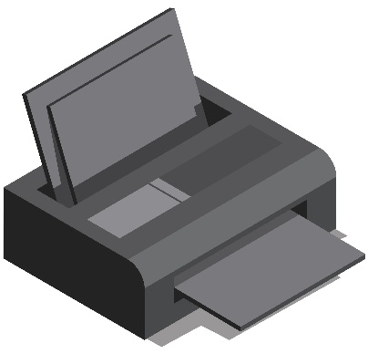 | …………………………  Scanner  …………………………  …………………………
 | …………………………  Music  …………………………  ………………………… | 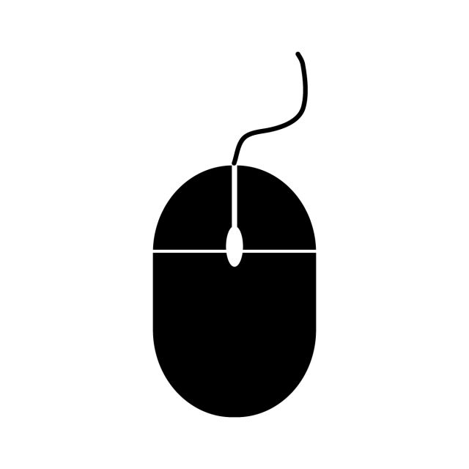 | …………………………  Mouse  …………………………  …………………………
 | …………………………  Recycle Bin  …………………………  ………………………… | 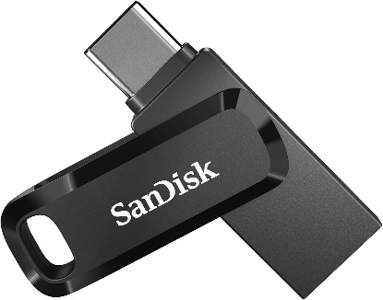 | …………………………  Flash Drive  …………………………  …………………………

Good Luck

